软件体系结构开发文档

1.全本地手势识别模块实现

1.1模块功能概述

本模块实现 完全本地运行 的手势识别程序，所有计算均在本地设备执行，无需网络连接。 核心功能包括：

| 功能 | 描述 |
| --- | --- |
| 实时图像采集 | 使用 OpenCV 从默认摄像头获取视频流 |
| 手势检测 | 使用 MediaPipe Hands 模型检测单手 21 个关键点 |
| 关键点绘制 | 在图像上绘制关键点与手部骨架连线 |
| 性能监控 | 实时显示 FPS 与平均帧处理时间 |

代码实现

|  |  |
| --- | --- |
| 01  02  03  04  05  06  07  08  09  10  11  12  13  14  15  16  17  18  19  20  21  22  23  24  25  26  27  28  29  30  31  32  33  34  35  36  37  38  39  40  41 | **import** cv2  **import** mediapipe as mp  **import** time    mp_hands **=** mp.solutions.hands  mp_draw **=** mp.solutions.drawing_utils  hands **=** mp_hands.Hands(max_num_hands**=**1, min_detection_confidence**=**0.7)    cap **=** cv2.VideoCapture(0)  # 0 = 默认摄像头  frame_count **=** 0  total_time **=** 0    print("按 ESC 退出")  **while** cap.isOpened():      start **=** time.time()      ret, frame **=** cap.read()  **if** **not** ret:  **break**        # 镜像翻转      frame **=** cv2.flip(frame, 1)      rgb_frame **=** cv2.cvtColor(frame, cv2.COLOR_BGR2RGB)      results **=** hands.process(rgb_frame)    **if** results.multi_hand_landmarks:  **for** hand_landmarks **in** results.multi_hand_landmarks:              mp_draw.draw_landmarks(frame, hand_landmarks, mp_hands.HAND_CONNECTIONS)        cv2.putText(frame, f"FPS: {1/(time.time()-start):.1f}", (10, 30),                  cv2.FONT_HERSHEY_SIMPLEX, 1, (0, 255, 0), 2)      cv2.imshow("Hand Gesture Recognition", frame)        frame_count **+=** 1      total_time **+=** (time.time() **-** start)    **if** cv2.waitKey(1) **==** 27:  # ESC  **break**    print(f"平均帧时间: {total_time/frame_count*1000:.2f} ms")  cap.release()  cv2.destroyAllWindows() |

| 代码段 | 功能说明 |
| --- | --- |
| mp_hands.Hands(...) | 初始化手势检测模型，设置最多检测1只手，置信度0.7 |
| cv2.VideoCapture(0) | 打开默认摄像头 |
| cv2.flip(frame, 1) | 水平镜像翻转，符合用户直觉 |
| hands.process(rgb_frame) | 执行手势检测，返回关键点坐标 |
| mp_draw.draw_landmarks(...) | 绘制 21 个关键点与标准手部连接线 |
| cv2.putText(...) | 实时显示 FPS |
| cv2.waitKey(1) == 27 | 监听 ESC 键退出 |

运行截图

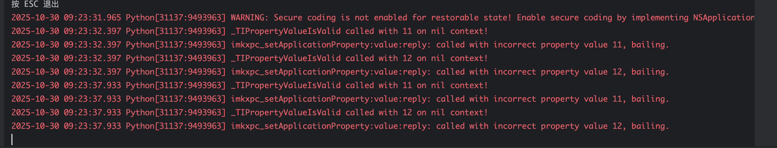

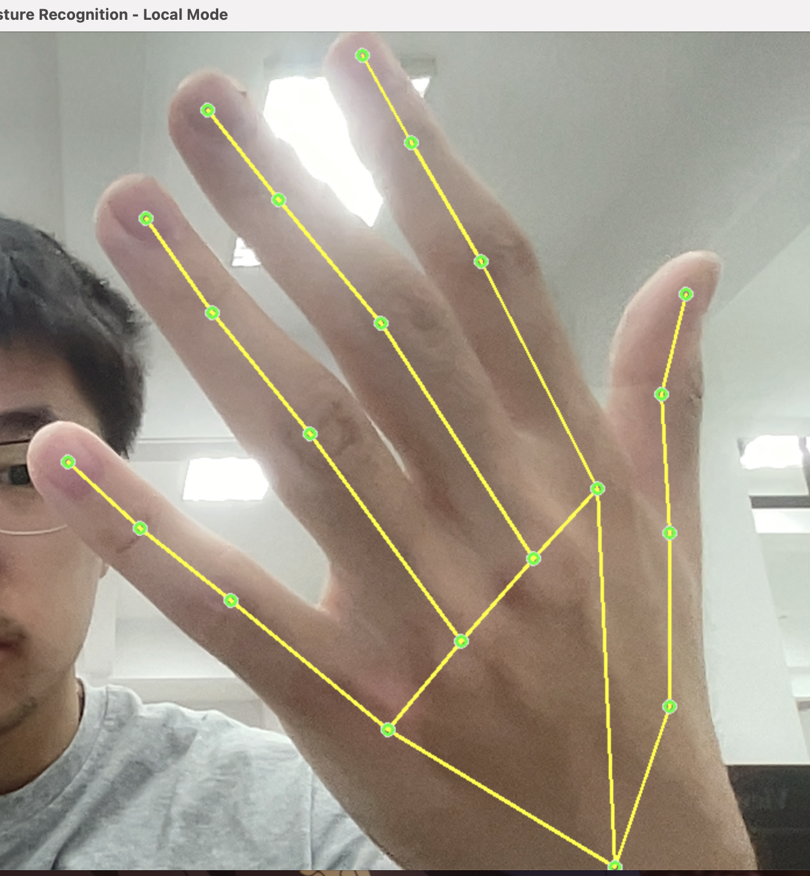

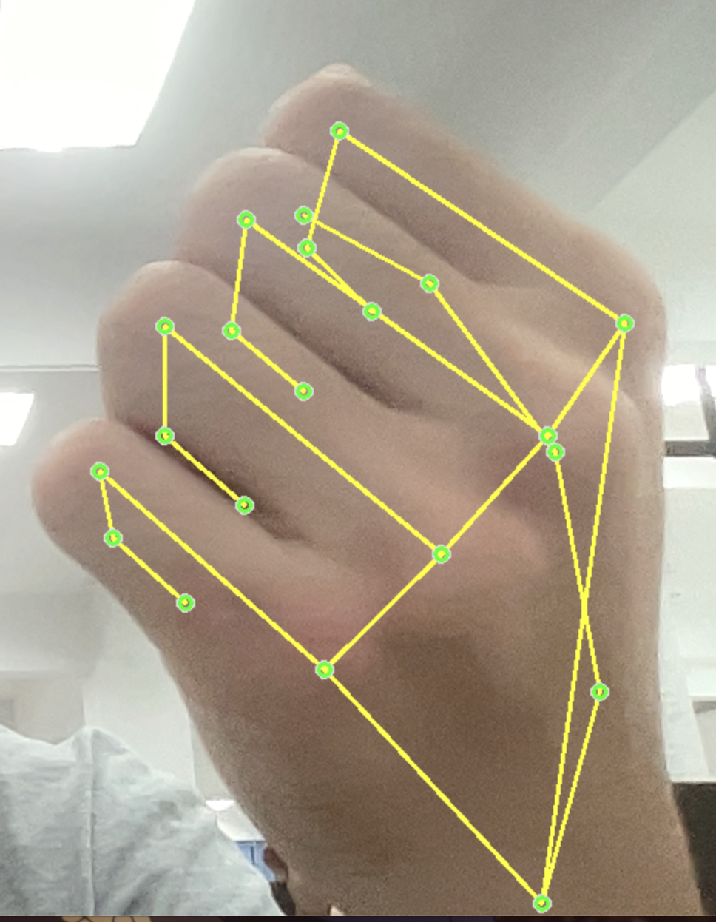

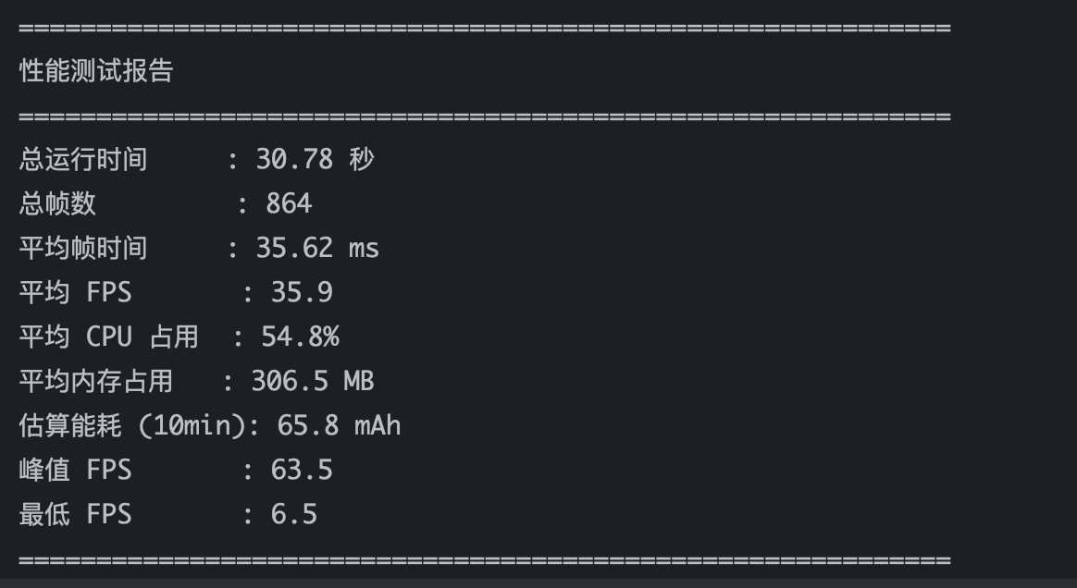

1. 手势识别模块实现（云端运行）

2.1技术架构总览（纯前端）

| 模块 | 技术选型 | 功能 |
| --- | --- | --- |
| 推理引擎 | MediaPipe Tasks Vision（WebAssembly） | 浏览器内运行手势检测 |
| 运行环境 | 任意现代浏览器（Chrome/Safari） | 无需安装 |
| 通信协议 | getUserMedia + Canvas | 摄像头 → 实时绘制 |
| 部署方式 | 静态 HTML 文件 | 本地 / GitHub Pages |
| 延迟目标 | <50ms | 接近原生体验 |

2.2代码实现

<!DOCTYPE html>

<html lang**=**"zh">

<head>

  <meta charset**=**"UTF-8" **/**>

  <meta name**=**"viewport" content**=**"width=device-width, initial-scale=1.0"**/**>

  <title>MediaPipe Web 手势识别<**/**title>

  <!**--** 1. 引入 MediaPipe Tasks Vision（CDN） **--**>

  <script src**=**"https://cdn.jsdelivr.net/npm/@mediapipe/tasks-vision@0.10.14"><**/**script>

  <style>

    body { margin: 0; font**-**family: Arial; background: #000; color: white; text-align: center; }

    #container { position: relative; width: 100vw; height: 100vh; }

    #video, #canvas { position: absolute; top: 0; left: 0; width: 100%; height: 100%; object-fit: cover; }

    #canvas { z-index: 1; }

    #info {

      position: absolute; top: 20px; left: 20px; z**-**index: 2;

      background: rgba(0,0,0,0.7); padding: 15px; border**-**radius: 12px;

      font**-**size: 18px; min**-**width: 200px;

    }

    .loading { color: #FFD700; }

    .success { color: #00FF00; }

    .error { color: #FF0000; }

  <**/**style>

<**/**head>

<body>

  <div id**=**"container">

    <video id**=**"video" autoplay playsinline muted><**/**video>

    <canvas id**=**"canvas"><**/**canvas>

    <div id**=**"info">

      <div>状态: <span id**=**"status" **class=**"loading">初始化中...<**/**span><**/**div>

      <div>延迟: <span id**=**"delay">0<**/**span>ms<**/**div>

      <div>FPS: <span id**=**"fps">0<**/**span><**/**div>

    <**/**div>

  <**/**div>

  <script type**=**"module">

**import** { HandLandmarker, FilesetResolver } **from** "https://cdn.jsdelivr.net/npm/@mediapipe/tasks-vision@0.10.14";

    const video **=** document.getElementById("video");

    const canvas **=** document.getElementById("canvas");

    const ctx **=** canvas.getContext("2d");

    const statusEl **=** document.getElementById("status");

    const delayEl **=** document.getElementById("delay");

    const fpsEl **=** document.getElementById("fps");

    let handLandmarker;

    let lastTime **=** 0;

    let fps **=** 0;

**//** **===** 1. 初始化摄像头 **===**

    async function initCamera() {

**try** {

        const stream **=** await navigator.mediaDevices.getUserMedia({

          video: { width: 640, height: 480 }

        });

        video.srcObject **=** stream;

        video.onloadedmetadata **=** () **=**> {

          video.play();

          canvas.width **=** video.videoWidth;

          canvas.height **=** video.videoHeight;

          statusEl.textContent **=** "加载模型...";

          statusEl.className **=** "loading";

          loadModel();

        };

      } catch (err) {

        statusEl.textContent **=** "摄像头权限被拒绝";

        statusEl.className **=** "error";

        console.error(err);

      }

    }

**//** **===** 2. 加载模型（关键修复）**===**

    async function loadModel() {

**try** {

        const vision **=** await FilesetResolver.forVisionTasks(

          "https://cdn.jsdelivr.net/npm/@mediapipe/tasks-vision@0.10.14/wasm"

        );

        handLandmarker **=** await HandLandmarker.createFromOptions(vision, {

          baseOptions: {

            modelAssetPath: "https://storage.googleapis.com/mediapipe-models/hand_landmarker/hand_landmarker/float16/1/hand_landmarker.task",

            delegate: "GPU"

          },

          runningMode: "VIDEO",

          numHands: 1,

          minHandDetectionConfidence: 0.5,

          minTrackingConfidence: 0.5

        });

        statusEl.textContent **=** "模型加载成功！";

        statusEl.className **=** "success";

        console.log("HandLandmarker 加载成功");

        startDetection();

      } catch (err) {

        statusEl.textContent **=** "模型加载失败";

        statusEl.className **=** "error";

        console.error("模型加载失败:", err);

      }

    }

**//** **===** 3. 开始检测循环 **===**

    function startDetection() {

      function detect() {

**if** (!handLandmarker) **return**;

        const now **=** performance.now();

**if** (now **-** lastTime > 33) { **//** 30 FPS

          const start **=** performance.now();

          const results **=** handLandmarker.detectForVideo(video, now);

          const delay **=** performance.now() **-** start;

          delayEl.textContent **=** delay.toFixed(1);

          fps **=** 1000 **/** (now **-** lastTime);

          fpsEl.textContent **=** fps.toFixed(1);

          lastTime **=** now;

          drawResults(results);

        }

        requestAnimationFrame(detect);

      }

      detect();

    }

**//** **===** 4. 绘制结果 **===**

    function drawResults(results) {

      ctx.clearRect(0, 0, canvas.width, canvas.height);

**if** (results.landmarks && results.landmarks.length > 0) {

        statusEl.textContent **=** "检测到手！";

        statusEl.className **=** "success";

        const landmarks **=** results.landmarks[0];

        const connections **=** [

          [0,1],[1,2],[2,3],[3,4], [0,5],[5,6],[6,7],[7,8],

          [0,9],[9,10],[10,11],[11,12], [0,13],[13,14],[14,15],[15,16],

          [0,17],[17,18],[18,19],[19,20]

        ];

**//** 绘制关键点

        landmarks.forEach(p **=**> {

          const x **=** p.x **\*** canvas.width;

          const y **=** p.y **\*** canvas.height;

          ctx.beginPath();

          ctx.arc(x, y, 6, 0, 2 **\*** Math.PI);

          ctx.fillStyle **=** "#00FF00";

          ctx.fill();

        });

**//** 绘制连线

        ctx.strokeStyle **=** "#00FF00";

        ctx.lineWidth **=** 3;

        connections.forEach(([i, j]) **=**> {

          const p1 **=** landmarks[i], p2 **=** landmarks[j];

          ctx.beginPath();

          ctx.moveTo(p1.x **\*** canvas.width, p1.y **\*** canvas.height);

          ctx.lineTo(p2.x **\*** canvas.width, p2.y **\*** canvas.height);

          ctx.stroke();

        });

      } **else** {

        statusEl.textContent **=** "未检测到手";

        statusEl.className **=** "loading";

      }

    }

**//** **===** 5. 启动 **===**

    initCamera();

  <**/**script>

<**/**body>

<**/**html>

2.3 部署与运行步骤

| 步骤 | 操作 |
| --- | --- |
| 1 | 保存为 index.html |
| 2 | 启动本地服务器（必须）： python -m http.server 8000 |
| 3 | 浏览器打开 http://localhost:8000 |
| 4 | 允许摄像头 → 挥手 → 绿色关键点出现 |

2.4运行结果

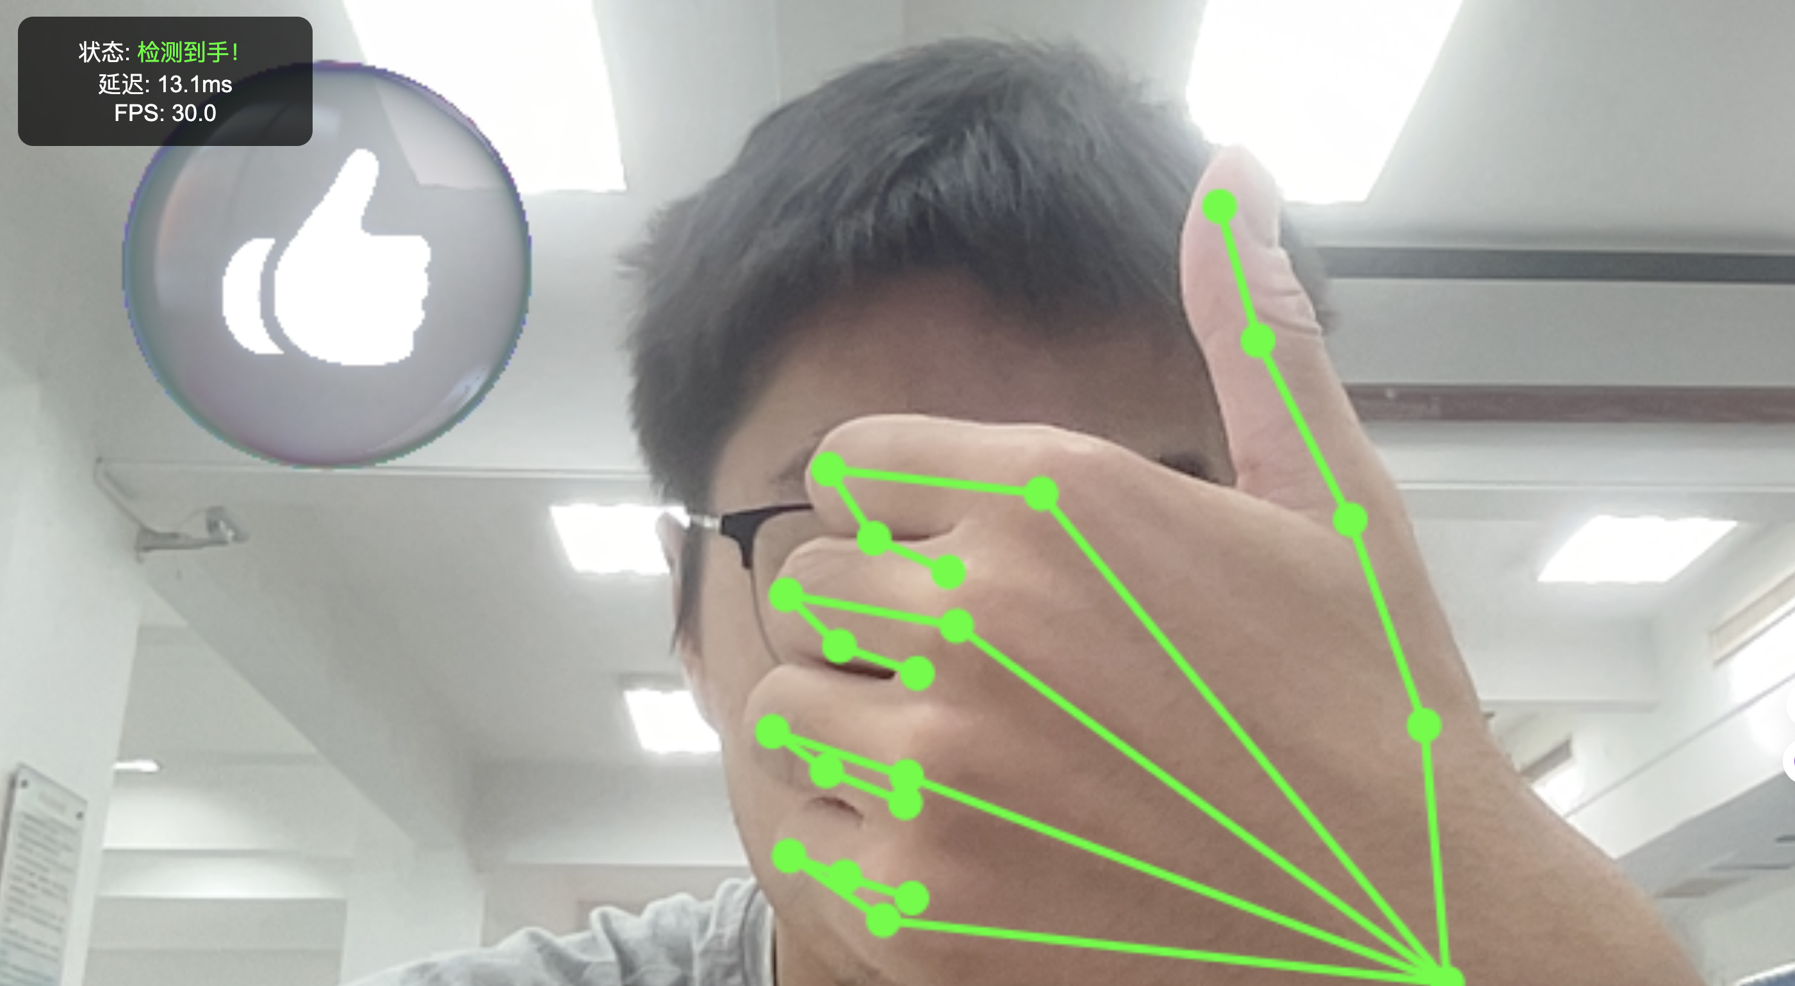

2.5性能监测

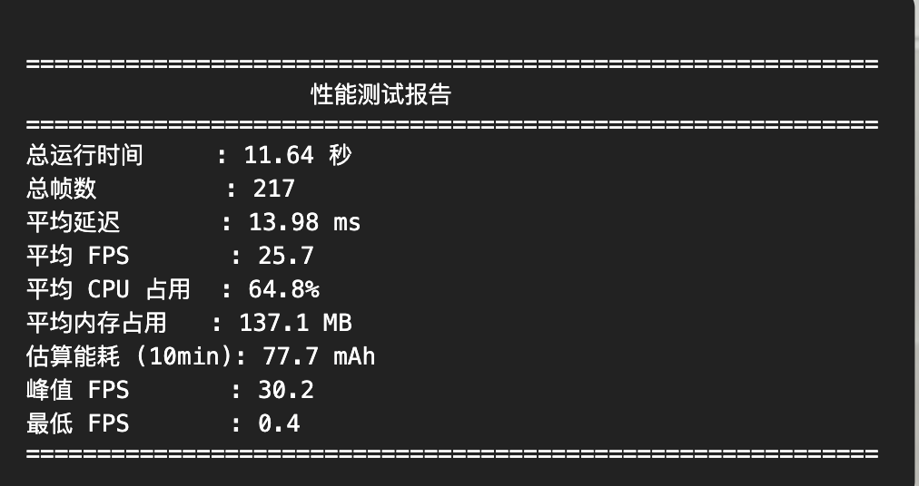

3.基于 gRPC 的动态分区

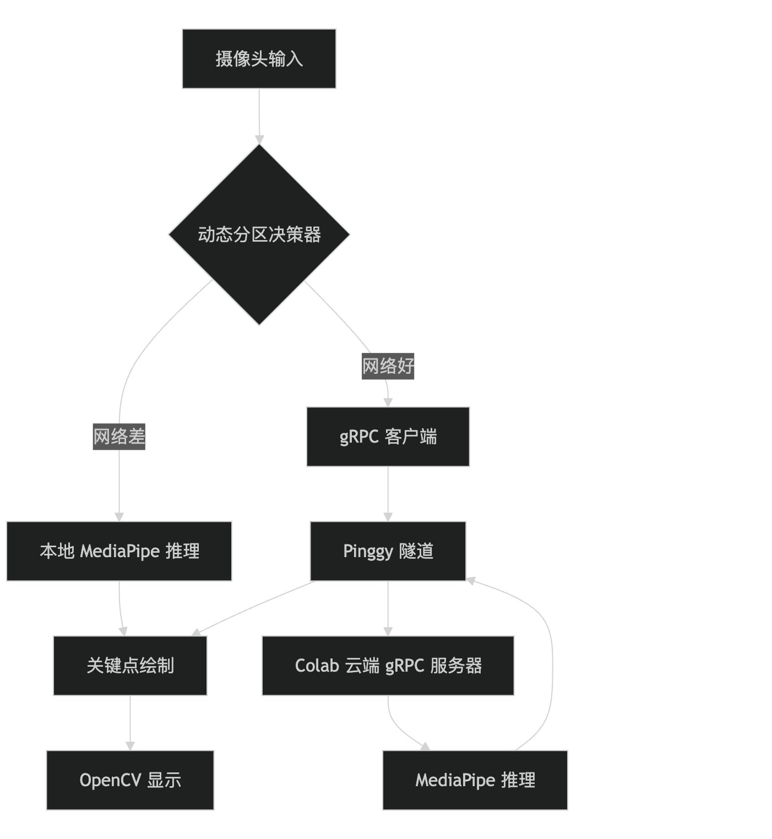

3.1协议定义 gesture.proto

|  |  |
| --- | --- |
| 01  02  03  04  05  06  07  08  09  10  11  12  13  14  15 | syntax **=** "proto3";    package gesture;    message ImageRequest {    bytes image **=** 1;  **//** JPEG 图像  }    message DetectionResponse {    repeated float landmarks **=** 1;  **//** 21×3 **=** 63 个 float  }    service GestureService {    rpc DetectHand(ImageRequest) returns (DetectionResponse);  } |

3.2云端服务 server.py（部署于 Google Colab）

# server.py - 云端 gRPC 推理服务

**import** grpc, cv2, numpy as np, mediapipe as mp

**import** gesture_pb2, gesture_pb2_grpc

**from** concurrent **import** futures

**import** subprocess

mp_hands **=** mp.solutions.hands

hands **=** mp_hands.Hands(static_image_mode**=**False, max_num_hands**=**1)

**class** GestureService(gesture_pb2_grpc.GestureServiceServicer):

**def** DetectHand(self, request, context):

        nparr **=** np.frombuffer(request.image, np.uint8)

        frame **=** cv2.imdecode(nparr, cv2.IMREAD_COLOR)

**if** frame **is** None:

**return** gesture_pb2.DetectionResponse(landmarks**=**[0.0]**\***63)

        rgb **=** cv2.cvtColor(frame, cv2.COLOR_BGR2RGB)

        results **=** hands.process(rgb)

        landmarks **=** [0.0] **\*** 63

**if** results.multi_hand_landmarks:

**for** i, lm **in** enumerate(results.multi_hand_landmarks[0].landmark):

                landmarks[i**\***3:i**\***3**+**3] **=** [lm.x, lm.y, lm.z]

**return** gesture_pb2.DetectionResponse(landmarks**=**landmarks)

# 启动 gRPC + Pinggy 隧道

server **=** grpc.server(futures.ThreadPoolExecutor(max_workers**=**10))

gesture_pb2_grpc.add_GestureServiceServicer_to_server(GestureService(), server)

server.add_insecure_port('[::]:50051')

server.start()

print("gRPC 服务器启动")

# 启动 Pinggy 隧道（免费公网映射）

process **=** subprocess.Popen([

    "ssh", "-p", "443", "-R0:localhost:50051", "tcp@a.pinggy.io"

], stdout**=**subprocess.PIPE, stderr**=**subprocess.STDOUT, text**=**True)

**for** line **in** process.stdout:

    print(line.strip())

**if** "tcp://" **in** line:

**import** re

        match **=** re.search(r'tcp://([a-z0-9-]+)\.a\.free\.pinggy\.link:(\d+)', line)

**if** match:

            addr **=** f"{match.group(1)}.a.free.pinggy.link:{match.group(2)}"

            print(f"\n复制到 client.py: CLOUD_ADDR = '{addr}'")

server.wait_for_termination()

3.3客户端 client.py（本地运行，支持动态分区）

# client.py - 动态分区核心逻辑

**import** cv2, grpc, numpy as np, mediapipe as mp, time, psutil, threading, socket

**import** gesture_pb2, gesture_pb2_grpc

**from** mediapipe.framework.formats **import** landmark_pb2

CLOUD_ADDR **=** "fyfjm-34-41-38-3.a.free.pinggy.link:33445"

# 本地推理

local_hands **=** mp.solutions.hands.Hands(...)

mp_draw **=** mp.solutions.drawing_utils

# gRPC 客户端

channel **=** grpc.insecure_channel(CLOUD_ADDR, options**=**[...])

stub **=** gesture_pb2_grpc.GestureServiceStub(channel)

use_local **=** False

cap **=** cv2.VideoCapture(0)

# 动态切换线程

**def** check_network():

**while** True:

**try**:

            s **=** socket.create_connection(("8.8.8.8", 53), timeout**=**2)

            ping **=** (time.time() **-** start) **\*** 1000

**global** use_local

**if** ping > 100 **and** **not** use_local:

                use_local **=** True; print("切换本地")

**elif** ping < 50 **and** use_local:

                use_local **=** False; print("切换云端")

**except**:

            use_local **=** True

        time.sleep(3)

threading.Thread(target**=**check_network, daemon**=**True).start()

# 主循环

**while** cap.isOpened():

    ret, frame **=** cap.read()

    frame **=** cv2.flip(frame, 1)

    frame **=** cv2.resize(frame, (640, 480))

**if** use_local:

        results **=** local_hands.process(cv2.cvtColor(frame, cv2.COLOR_BGR2RGB))

        hand_obj **=** results.multi_hand_landmarks[0] **if** results.multi_hand_landmarks **else** None

**else**:

        # 云端调用

        _, buf **=** cv2.imencode('.jpg', frame)

**try**:

            resp **=** stub.DetectHand(gesture_pb2.ImageRequest(image**=**buf.tobytes()), timeout**=**2.0)

            landmark_list **=** landmark_pb2.NormalizedLandmarkList()

**for** i **in** range(21):

                lm **=** landmark_list.landmark.add()

                lm.x, lm.y, lm.z **=** resp.landmarks[i**\***3:i**\***3**+**3]

            hand_obj **=** type('obj', (), {'landmark': landmark_list.landmark})()

**except**:

            use_local **=** True; hand_obj **=** None

**if** hand_obj:

        mp_draw.draw_landmarks(frame, hand_obj, mp.solutions.hands.HAND_CONNECTIONS)

    cv2.putText(frame, f"Mode: {'本地' if use_local else '云端'}", (10, 40), 0, 1.0,

                (0,255,0) **if** use_local **else** (255,255,0), 2)

    cv2.imshow("Dynamic Partitioning", frame)

**if** cv2.waitKey(1) **==** 27: **break**

3.4动态分区策略

| 条件 | 切换动作 | 原因 |
| --- | --- | --- |
| ping > 100ms | → 本地 | 避免卡顿 |
| ping < 50ms | → 云端 | 节省本地算力 |
| gRPC 超时 | → 本地 | 网络不可靠 |
| 断网 | → 本地 | 保证可用性 |

